1. HTML/CSS **4 hours**

1. Review of HTML Tags (formatting, links, images, table, forms, frames etc.), Getting started with HTML5, CSS 3, Responsive design, and Browser compatibility

# <https://www.javatpoint.com/what-is-html>

# **What is HTML**

HTML is an acronym which stands for **Hyper Text Markup Language** which is used for creating web pages and web applications. Let's see what is meant by Hypertext Markup Language, and Web page.

**Hyper Text:** HyperText simply means "Text within Text." A text has a link within it, is a hypertext. Whenever you click on a link which brings you to a new webpage, you have clicked on a hypertext. HyperText is a way to link two or more web pages (HTML documents) with each other.

**Markup language:** A markup language is a computer language that is used to apply layout and formatting conventions to a text document. Markup language makes text more interactive and dynamic. It can turn text into images, tables, links, etc.

**Web Page:** A web page is a document which is commonly written in HTML and translated by a web browser. A web page can be identified by entering an URL. A Web page can be of the static or dynamic type. **With the help of HTML only, we can create static web pages**.

Hence, HTML is a markup language which is used for creating attractive web pages with the help of styling, and which looks in a nice format on a web browser. An HTML document is made of many HTML tags and each HTML tag contains different content.

## Description of HTML Example

**<!DOCTYPE>:** It defines the document type or it instruct the browser about the version of HTML.

**<html >** :This tag informs the browser that it is an HTML document. Text between html tag describes the web document. It is a container for all other elements of HTML except <!DOCTYPE>

**<head>:** It should be the first element inside the <html> element, which contains the metadata(information about the document). It must be closed before the body tag opens.

**<title>:** As its name suggested, it is used to add title of that HTML page which appears at the top of the browser window. It must be placed inside the head tag and should close immediately. (Optional)

**<body>**: Text between body tag describes the body content of the page that is visible to the end user. This tag contains the main content of the HTML document.

**<h1>** : Text between <h1> tag describes the first level heading of the webpage.

**<p>**: Text between <p> tag describes the paragraph of the webpage.

## Brief History of HTML

In the late 1980's , a physicist, Tim Berners-Lee who was a contractor at CERN, proposed a system for CERN researchers. In 1989, he wrote a memo proposing an internet based hypertext system.

**Tim Berners-Lee** is known as the father of HTML. The first available description of HTML was a document called "HTML Tags" proposed by Tim in late 1991. The latest version of HTML is HTML5, which we will learn later in this tutorial.

## HTML Versions

Since the time HTML was invented there are lots of HTML versions in market, the brief introduction about the HTML version is given below:

**HTML 1.0:** The first version of HTML was 1.0, which was the barebones version of HTML language, and it was released in1991.

**HTML 2.0:** This was the next version which was released in 1995, and it was standard language version for website design. HTML 2.0 was able to support extra features such as form-based file upload, form elements such as text box, option button, etc.

**HTML 3.2:** HTML 3.2 version was published by W3C in early 1997. This version was capable of creating tables and providing support for extra options for form elements. It can also support a web page with complex mathematical equations. It became an official standard for any browser till January 1997. Today it is practically supported by most of the browsers.

**HTML 4.01:** HTML 4.01 version was released on December 1999, and it is a very stable version of HTML language. This version is the current official standard, and it provides added support for stylesheets (CSS) and scripting ability for various multimedia elements.

**HTML5 :** HTML5 is the newest version of HyperText Markup language. The first draft of this version was announced in January 2008. There are two major organizations one is W3C (World Wide Web Consortium), and another one is WHATWG( Web Hypertext Application Technology Working Group) which are involved in the development of HTML 5 version, and still, it is under development.

## Features of HTML

1) It is a very **easy and simple language**. It can be easily understood and modified.

2) It is very easy to make an **effective presentation** with HTML because it has a lot of formatting tags.

3) It is a **markup language**, so it provides a flexible way to design web pages along with the text.

4) It facilitates programmers to add a **link** on the web pages (by html anchor tag), so it enhances the interest of browsing of the user.

5) It is **platform-independent** because it can be displayed on any platform like Windows, Linux, and Macintosh, etc.

6) It facilitates the programmer to add **Graphics, Videos, and Sound** to the web pages which makes it more attractive and interactive.

7) HTML is a case-insensitive language, which means we can use tags either in lower-case or upper-case.

**Difference between HTML and HTML5**

People new to the realms of web design often hear the word “markup” and wonder what it means and how it is different from the more commonly known term “code.” Predominantly, a markup language is designed to process, define and present text; tag embedding and text annotations are carried out within styled files to make text manipulation easy for the computer. Historically, the phrase markup language takes inspiration from the process of manuscript marking-up via which printer instructions were derived from handwritten markups. HTML is the most commonly used markup language. A few years ago an update for this language titled HTML5 was released. In this tutorial, we will overview the difference between HTML and HTML5.

**What is HTML?**

HTML or Hyper-Text Markup Language can be referred to as the Worldwide Web’s primary language. Most of the web pages hosted on the internet are written in some variation of HTML. Via HTML, developers ensure exactly how multimedia, text, and hyperlink among other things get displayed in web browsers. From the elements that establish connections with your document (hypertext) to the ones that make these documents interactive (e.g. forms); all are constituents of HTML.

The HTML standard was developed by W3C or the World Wide Web Consortium in 1997. In HTML, tags are used to define text structures; tags, and elements are defined using the < and > characters. Some of the examples for the previously mentioned tags are headings, tables, and paragraphs, etc. Browsers are responsible for rendering of the web page content via these tags.

Since long, HTML has not been the only web development standard. In the early days, all the content and style tags were present in one giant, cumbersome (and often complicated) language. Over time, W3C came to the decision that segregation between the content and style of a web page was necessary; this led to the creation of style sheets. These days, tags that are used for defining the style of a document (e.g. FONT) have almost gotten deprecated as people have started preferring style sheets and only the content defining tags (e.g. H1) still form the core HTML.

HTML has seen many updates over time, and currently, the newest HTML version is HTML5. HTML5 is of course still primarily a markup language, but it has added a plethora of features to the original HTML and has eradicated some of the strictness that was present in XHTML. Every day, new features get added to HTML5, but there aren’t any new numbered releases rolled out there. The main difference between HTML and HTML5 can be that neither audio nor video is a constituent of HTML whereas both can be considered integral parts of HTML5.

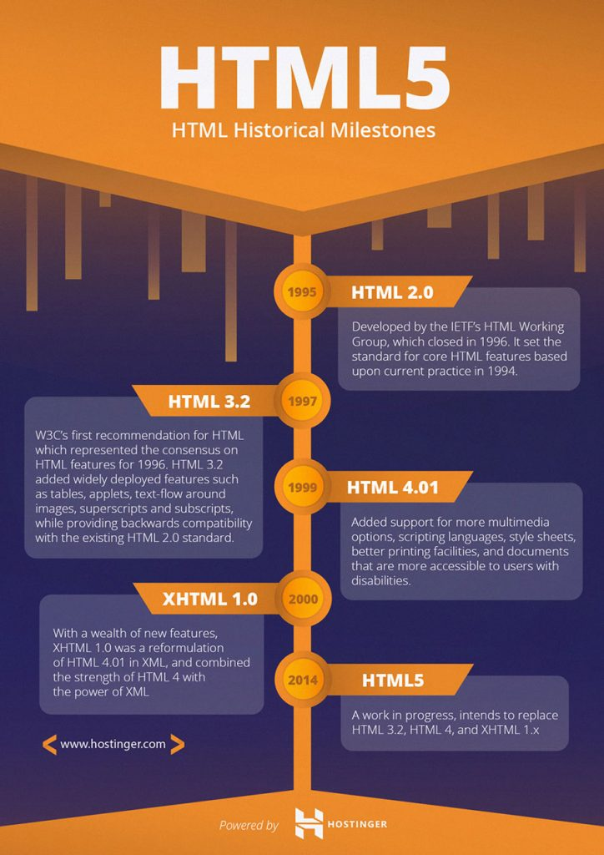

**What are the main differences between HTML and HTML5**

The one consistent thing about the field of information technology is that periodic updates/changes are inevitable. No language is capable of avoiding upgrades and/or new releases. HTML is no exception. HTML5 was released with the primary objective of improving the World Wide Web experience for the developers and the end users. As already mentioned, the biggest advantage that HTML5 has over its unnumbered predecessor is that it has high-level audio and video support which was not a part of the version specifications in previous HTMLs. Other differences between HTML and HTML5:

1. SVG, canvas and other virtual vector graphics are supported in HTML5, whereas in HTML, using vector graphics was only possible by using it in conjunction with different technologies like Flash, VML, and Silver-light, etc.
2. HTML5 uses web SQL databases, application cache for temporary storing data, meanwhile, in HTML, only browser cache could be utilized for this purpose.
3. Another difference between HTML and HTML5 worth mentioning is that the former doesn’t allow JavaScript to run within the web browser (it instead runs in the browser interface thread) whereas the latter provides full support for JavaScript to run in the background (This is possible courtesy to the JS web worker API of HTML5).
4. HTML5 is not based on SGML, and that allows it to have improved parsing rules which provide enhanced compatibility.
5. In HTML5, inline MathML and SVG can be used in text whereas this wasn’t possible in HTML.
6. Some of the deprecated elements that have now been dropped completely are: isindex, noframes, acronym, applet, basefont, dir, font, frame, frameset, big, center, strike, tt.
7. HTML5 supports new kinds of form controls, for example: dates and times, email, number, range, tel, url, search etc.
8. There are many new elements introduced in HTML. Some of the most important ones are: summary, time, aside, audio, command, data, datalist, details, embed, wbr, figcaption, figure, footer, header, article, hgroup, bdi, canvas, keygen, mark, meter, nav, output, progress, rp, rt, ruby, section, source, track, video.

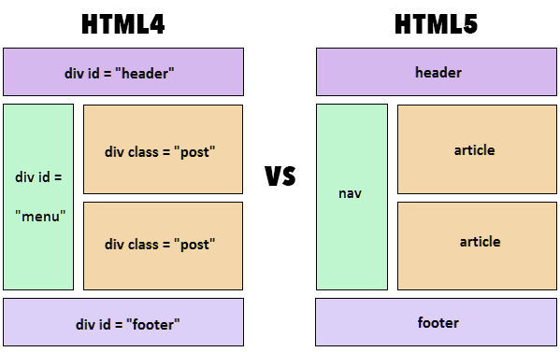

**Key Advantages Provided by HTML5 for Developers**

HTML5 wanted developers to have more flexibility while designing websites and there have been significant improvements that are worth noticing:

1. **Persistent error handling:** Most of the browsers have the support to parse structurally/syntactically incorrect HTML code, but until a few years ago, there was no standardized process to handle this. It meant that new browser developers had to perform malformed HTML document tests in different browsers in the bid to create improved error handling processes via the marvels of reverse engineering. The consistent HTML5 error handling has made a huge difference in this regard.The improved parsing algorithms that are used in HTML5 have unquantifiable benefits. Surveys reveal that around 90 percent of websites are liable to comprise of some incorrectly written code (tag soup) so being able to handle errors aptly is imperative. Furthermore, inherent error handling saves developers a lot of money and tons of time.
2. **Improved semantics for elements:** To enhance code insinuation, improvements have been made to the semantic roles of various existing elements. Section, article, nav and header are the new elements that have replaced most of the now-obsolete div elements, and this has made the process of mistake-scanning a whole lot less complicated.
3. **Enhanced support for web application features:** One of the primary goals of HTML5 was to allow browsers to function as application platforms. Web sites in the past used to be a lot less complex but over time, the cumbersomeness has increased. HTML5 provides developers with enhanced control of their websites’ performance. In the past, the developers had to use workarounds because many server-side technologies and browser extensions were not present. Now, with HTML5, there is no use to employ any JS-based or Flash work-around (as previously done in HTML4) because there are elements inherently present in HTML5 that provide all the functionalities.
4. **Mobile web made easier:** Even today, creating a mobile version of a website can be a headache for developers. The smartphone-owning demographic has seen exponential proliferation over the past decade, and that created a need for improved HTML standards. End users want to be able to access a web resource at any time and via any device which makes having responsive websites a requirement. HTML5 has made mobile support a lot simpler by being able to cater to the low-powered electronic devices like tablets and smartphones.
5. **The canvas element:** One of the most discussed features of HTML5 is the <canvas> element. The introduction of this unique tag has had an enormous impact on the use of Adobe Flash. Even though many websites still use Flash, HTML5 has got the preference of many people, and it’s believed that soon Flash will run completely obsolete.Using the canvas element, a developer can draw graphics using different colors and shapes by making use of scripts (e.g. JavaScript). It’s worth mentioning that canvas is merely a graphic container and to define the graphics, a script has to be executed. An example where JavaScript is used in conjunction with canvas is:
6. **The Menu element:** The newly added <menu> and <menuitem> elements are constituents of the interactive elements specifications but aren’t often used or talked about by the developer community. However, these two items can be used to ensure enhanced web interactivity.The <menu> tag is used to represent menu commands in mobile and desktop applications for simplicity purposes. A possible usage of the menu tag can be:
7. **Customizable Data Attributes:**

It was possible to add custom attributes before HTML5, but it was a risky affair; for example, in HTML4, custom attributes would sometimes stop a page from rendering completely, and they could often become the cause of incorrect/invalid documents. The data-* attribute in HTML5 has brought an end to this often-occurring problem. There are multiple uses for this attribute, but the primary objective of its introduction was the storage of extra information about different elements. Now, custom data can be included, and it gives developers increased chances of making engaging and efficient web pages without having to introduce server-side lookups or Ajax calls.

1. **Cookies were (or should be) bid adieu:**

Local storage support was a huge addition to HTML5. In the pre-HTML5 days, if developers wanted to store anything, they had to make use of cookies. Cookies can hold a small amount of data (not to mention, everybody hates them) and this made the localStorage object’s addition to HTML5 an even more welcome benefit. The localStorage object is a part of the global window namespace and can be accessed from wherever desired while using scripts.

**HTML5 Cheat Sheet**

Cheat sheets can be a great help if you are starting to learn new language. Use the below HTML5 style sheet to get started with HTML5. This cheat sheet has all most commonly used HTML (HTML5 included) tags.

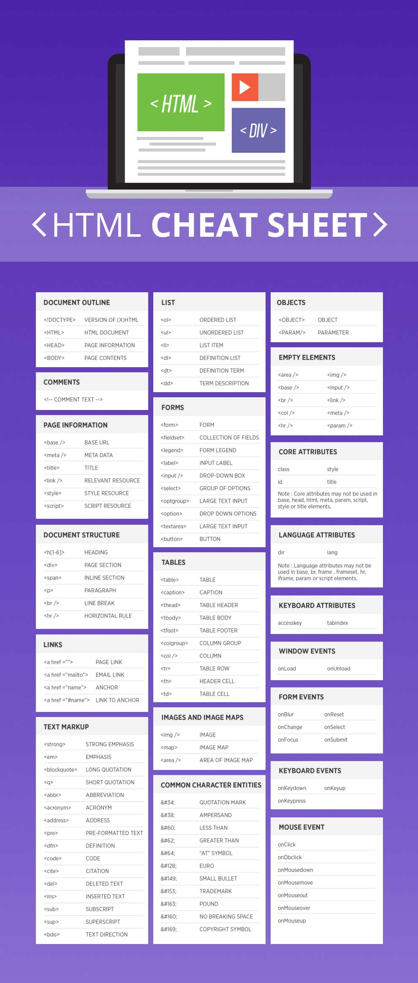

**HTML5 Advantages for End User**

HTML5 brought about a paradigm shift for both the developers and the end users. Some of the many advantages that it provides the end users are:

1. Mobile browsers now crash a lot less frequently than the native application. This wasn’t the case before, when there wasn’t enough mobile web development support provided by HTML.
2. The reliance on mobile websites is very high as almost 30 percent of mobile users detest downloading applications. So now if a user wants to use company’s services but doesn’t want to download their application, they can just log on to the company’s responsive website to do so.
3. The eradication of the need to use Adobe Flash allows developers to provide an aesthetic graphic-rich user experience. The use of JavaScript and MPEG4 in conjunction with HTML5 has made life a lot better for users.
4. The ability to support native audio and video elements means that the users won’t have to download additional plugins to view multimedia on your website. This rich media support provided by HTML5 is one of the biggest reasons why it’s used a lot more frequently than HTML in the world of today.

**Conclusion**

A newer version of any language can hardly not be better than its predecessor and HTML5 is certainly not an exception to the fact. With every passing year, developers will unravel new ways to benefit from HTML5. Furthermore, social media is expected to change even further with the language shortly.

Where the wave of change has already hit many developers over the world, it’s still expected that HTML5 adoption will increase even more rapidly in the years to come. To maximize the potential of modern day browsers, it’s of paramount importance to adopt HTML5 as quickly as possible.